**Logic Design Midterm (software)**

**2023. 04. 10.**

**Show your solving process, not just only answer.**

**10 points/problem if not specified**

1. Convert the given number:

(a) A9.F616 to octal

(b) 72.38 to decimal

2. Simplify the following logic expressions. You may use any technology.

(a) F(W, X, Y, Z) = (X + (Y’ (Z + W)’ )’ )’

(b) F(W, X, Y, Z) = WX + XY + X’Z’ + WY’Z’

3. For the binary arithmetic operations with signed-2’s complement and 4-bit hardware.

(a) Design a binary subtractor using full adders

(b) Show A = +5, B = -4, and A – B

4. For an error detector of 6-3-1-1 BCD digits, the output F is 1 iff the four inputs represent an invalid code combination. The code and its truth table are: *(20 points)*

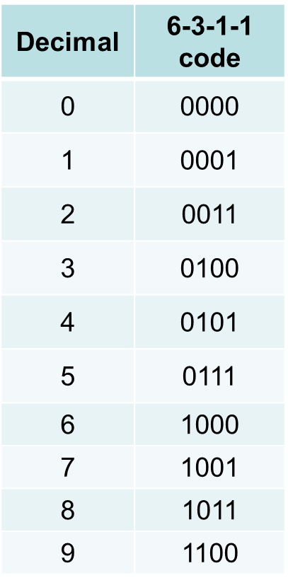

(a) Find the optimal solution.

(b) Realize it with NAND *or* NOR gates only.

5. For F(A, B, C, D) = Σ m(0, 10, 11) + Σ d(3, 4, 8, 13) *(20 points)*

(a) Find the optimal solution.

(b) Realize it with NOR gates only.

6. For F(A, B, C, D, E) = Σ m(0, 2, 3, 5, 11, 13, 20, 25) + Σ d(6, 7, 8, 26) *(20 points)*

(a) Find the optimal solution using QM-method.

(b) Realize it with NAND *or* NOR gates only.